**Batch:B2-2/H2_1 Roll No:-16010122151**

**Experiment 07**

|  |
| --- |
| **Title: To create an effective Dashboard.** |



# Objective:

# *Search/locate and download any Data of Your Choice (Use same dataset if it contains location information)*

# *To learn how to create Dashboard*

# *Apply best practices to create Dashboard.*



# Course Outcome:

# CO1: Learn how to locate and download datasets, extract insights from that data and present their findings in a variety of different formats.

# CO3: Apply data visualization best practices

# CO4: Design static charts, interactive Dashboards and data stories

# Books/ Journals/ Websites referred:

# 1) https://www.youtube.com/results?search_query=Dashboard+tableau

# 2) https://parade.com/1116816/marynliles/ -websites/

# Following points should be written by students

# Best practices of effective Dashboard.

# Create Dashboard.

# Create Accessible Dashboard.

# Create Dashboard Layouts for Different Device Types.

# Publish the dashboard online.

# Note: Detail observation (with interpretation) needed along screenshots wherever required

# DashBoard:-

**Whenever I hover over the map, in the map chart the country over which I am hovering will be shown in Wikipedia.**

The above Dashboard has the following chart:-

1)Maps

2)Bar Chart

3)Bubble Chart

4)Area

1)**Area Chart:-**

1. **Movie Dominance:-** The fact that the area representing movies is greater than the area for TV shows indicates that the number of movies produced each year significantly outweighs the number of TV shows during this time period.
2. 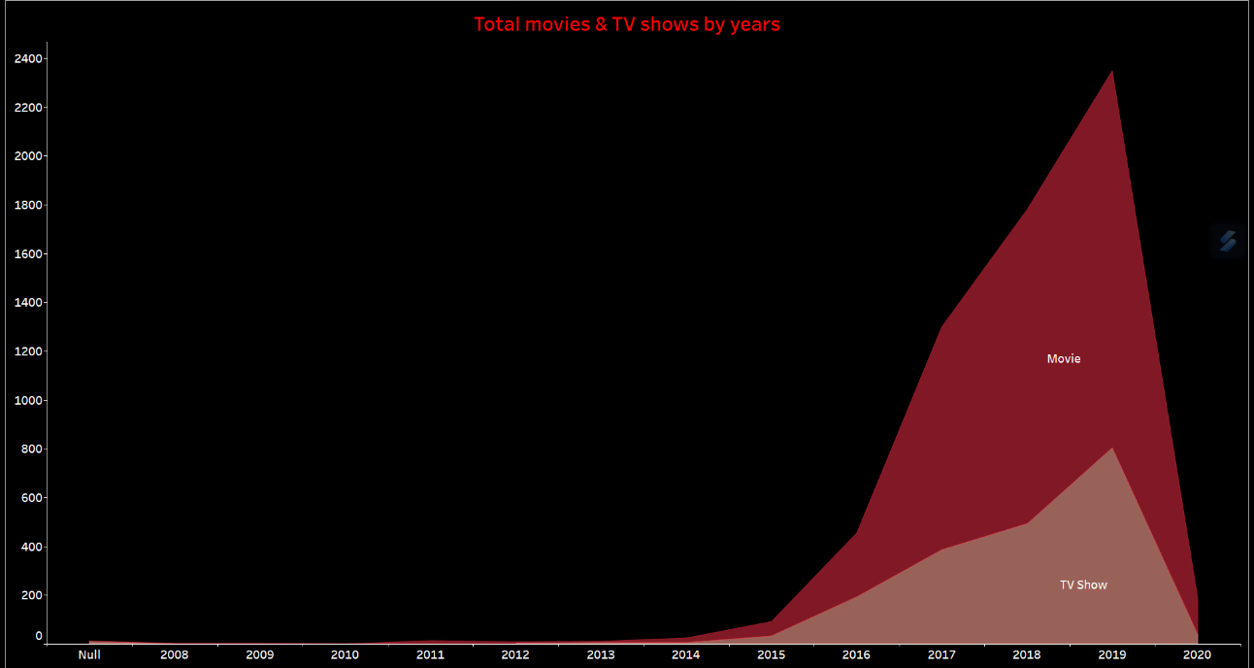**Trends Over Time:-**The area chart shows how the number of movies or TV shows has changed over the years.

# 2)Map Chart:-

# a) Geographic Distribution:- The map chart shows a visual representation of subscriptions across different geographical regions. The intensity of color or size of markers on the map corresponds to the number of subscriptions in each region.

# b) Subscription Leaders:- The chart clearly highlights the USA and India as the countries with the highest number of subscriptions. These regions are likely the primary markets for the service, indicating a significant user base.

# 3)Bar Chart:-

# a) Content Diversity:- The presence of other genres in the top 10 list demonstrates the diversity of available content. Each genre on the chart represents a different type of content that appeals to various audiences.

# b)Consumer Preferences:- The chart can reflect consumer preferences, showing which genres are in high demand and which genres content providers prioritize.

# 

# a)Viewership Rankings:- The bar chart displays a list of movies or TV shows, with each bar representing the relative viewership or popularity of each title. The titles with the tallest bars are the most-watched.

# b)Top Titles:- The chart highlights the top movies or TV shows that have garnered the highest viewership. These are likely to be the most popular and widely enjoyed among the audience.

# 

# 

# Conclusion (Students should write in their own words, comparative conclusion needed):- In simple terms, dashboards are like user-friendly, interactive tools that help you see and understand data better. They make it easy to explore information, but they can be a bit tricky to use at first. They're great for showing data trends and patterns, but if your data is too big or messy, they might not work as well. It's a helpful tool, but you need to learn how to use it effectively and make sure your data is in good shape.

# 

**Date: 23-10-2023 Signature of faculty in-charge**

# Post Lab Question:

# Explain the Advantages and Disadvantages of Dashboard

# Ans) Advantages:-

# User-Friendly Data Exploration: Tableau dashboards provide an intuitive, user-friendly interface for exploring and analyzing data. Users can create interactive visualizations without extensive technical knowledge, making it accessible to a broad audience.

# Interactivity: Tableau dashboards support interactive elements such as filters, parameters, and actions. This interactivity enables users to drill down into data, dynamically filter information, and gain deeper insights, enhancing the user experience.

# Data Integration: Tableau seamlessly connects to various data sources, making it easy to consolidate and visualize data from diverse origins. This integration capability enables comprehensive data analysis and reporting, which can be a significant advantage in data-driven decision-making.

# Disadvantages:-

# Learning Curve: While Tableau offers an intuitive interface, mastering advanced features and creating complex dashboards can be challenging. It often requires training and experience to leverage Tableau's full potential effectively.

# Performance Issues: Very large or complex dashboards may suffer from performance issues, including slower loading times and reduced responsiveness. Ensuring optimal performance can be a complex task, especially for novice users.

# Data Source Limitations: Dashboards in Tableau are dependent on data sources, and compatibility issues can arise when connecting to certain data formats or legacy systems. This can sometimes limit the scope of data analysis and reporting.